(Approx. 703 words)

Fisheye-Hemi Plug-In
by Neil Longmuir, Imaging SIG Laeder, Winnipeg PC User Group Inc., Canada
www.wpcusrgrp.org
longmur(at)ms.umanitoba.ca

Obtained from APCUG with the author's permission for publication by APCUG member groups.

The Fisheye-Hemi Photoshop plug-in from Image Trends Inc. corrects distortions present in fisheye lens images. This is a terrific plug-in filter that retains more of the original image resolution allowing the end user to display the original composition as seen through the viewfinder when the image was taken.

The Fisheye-Hemi plug-in package contains three plug-ins that support a wide variety of camera and lens combinations. The plug-in options are: Circle; Full frame; and Cropped.

Fisheye Lens History
In photography, a fisheye lens is defined as a wide-angle lens that takes in an extremely wide 180 degree angle. Fisheye lens were originally developed for use in astronomy and were called "whole-sky lenses." Fisheye lenses became popular in the late 1960's for general photography because of their unique distorted image appearance. Photographers often used fisheye lenses for taking broad landscapes to suggest the curve of the earth. Another very popular use of fisheye lenses was to photograph the interiors of churches.

As fisheye lenses became more popular in general photography, the major camera companies began to manufacture fisheye lenses to cover the entire 35 mm film frame. The first full-frame mass produced fisheye lens was the 16 mm made by Nikon in the late 1960s. The focal length of fisheye lenses made for the 35 mm film format typically are between 8 mm and 10 mm for circular lenses, and 15-16 mm for full-frame lenses. All the major camera manufacturers have fisheye lenses available for their cameras.
All ultra-wide angle lenses display some of distortion, although the latest computer designed and produced wide angle lenses have significantly less distortion than their older versions. Ultra-wide angle distortion can be corrected for moderately wide angles of view. On the other hand, rectilinear ultra-wide angle lenses with angles of view greater than 90 degrees are more difficult to design.

The first fisheye lenses to be developed were circular. These lenses took in a 180-degree angle and projected this angle was projected as a circle on to the film frame. Some of the early circular fisheye lenses were used in orthographic projection models for scientific applications.

The test images used in this review were taken with a Nikon D200 and the 10.5 mm f2.8 ED AF DX Nikon fisheye lens. This lens is an example of a cropped fisheye lens designed to be used with the APS sensors of digital cameras.

Actual Use of the Fisheye-Hemi plug-in
The Fisheye-Hemi plug-in is fully automatic and requires no end user intervention. The fisheye image used for this demonstration is the construction site of the new Manitoba Hydro office tower building being built in downtown Winnipeg, Manitoba. The construction site is a full city block.

I choose Fisheye-Hemi 3 (Cropped) to correct the image shown in figure 1.

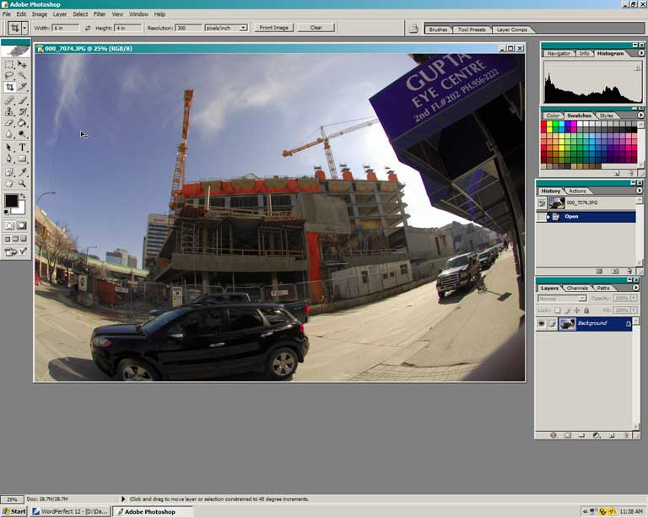

With this particular lens the full frame and cropped plug-in produced virtually the same after image. The only slight difference was the cropped plug-in produced a street that was less distorted. In the before image shown in Figure 1 the lines of the building are curved due to fisheye lens distortion. Figure 2 shows the image after applying Fisheye-Hemi (full frame) plug-in.

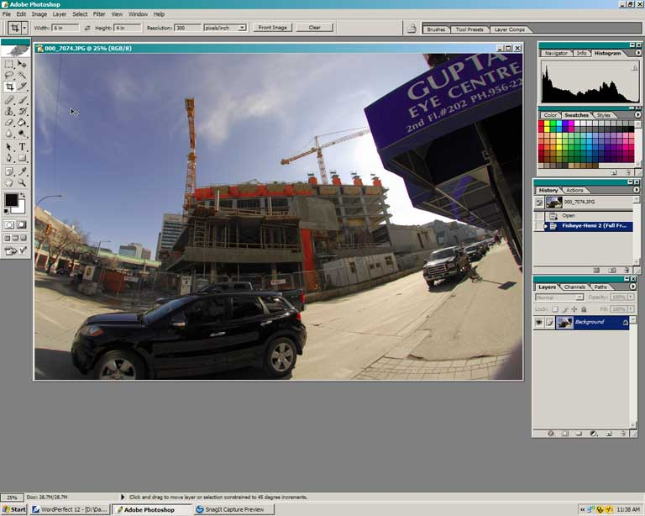

The Fisheye-Hemi plug-in costs $29 US. Be sure to visit www.imagetrendsinc.com and download the trial version. The plug-in works like a charm producing a very useable image without losing any visible resolution. Prints made from this image were clean and crisp with excellent sharpness. If you have a fisheye lens, then this plug-in is a must have.
Neil’s rating ***** plus a ☺

Contact
Image Trends Inc.
1 - 512 - 637 - 7300
www.imagetrendsinc.com

Note: I would like to thank Don’s Photo for the use of the Nikon 10.5 mm fisheye lens to take the images used for this review. I would also like to thank the kind folks at Image Trends Inc. for providing me a copy of the Fisheye-Hemi plug-in for review.

This article has been provided to APCUG by the author solely for publication by APCUG member groups. All other uses require the permission of the author (see e-mail address above).

